**UNIT-3**

Financial management: Sources of finance (Internal and External) - Preparation of Balance Sheet and Profit and Loss Statements, Types of Accounting and significance of each types, interest formulas and their applications.

# FINANCE MEANING;

According to Khan and Jain, “Finance is the art and science of managing money

**Webster’s** Ninth New Collegiate Dictionary defines finance as “the Science on study of the management of funds’ and the management of fund as the system that includes the circulation of money, the granting of credit, the making of investments, and the provision of banking facilities.

# OBJECTIVES OF FINANCIAL MANAGEMENT

Effective procurement and efficient use of finance lead to proper utilization of the finance by the business concern. It is the essential part of the financial manager. Hence, the financial manager must determine the basic objectives of the financial management. Objectives of Financial Management may be broadly divided into two parts such as:

1. Profit maximization
2. Wealth maximization.

# Profit Maximization

Main aim of any kind of economic activity is earning profit. A business concern is also functioning mainly for the purpose of earning profit. Profit is the measuring techniques to understand the business efficiency of the concern. Profit maximization is also the traditional and narrow approach, which aims at, maximizes the profit of the concern. Profit maximization consists of the following important features.

1. Profit maximization is also called as cashing per share maximization. It leads to maximize the business operation for profit maximization.
2. Ultimate aim of the business concern is earning profit, hence, it considers all the possible ways to increase the profitability of the concern.
3. Profit is the parameter of measuring the efficiency of the business concern. So it shows the entire position of the business concern.
4. Profit maximization objectives help to reduce the risk of the business

# Wealth Maximization

Wealth maximization is one of the modern approaches, which involves latest innovations and improvements in the field of the business concern. The term wealth means shareholder wealth or the wealth of the persons those who are involved in the business concern. Wealth maximization is also known as value maximization or net present worth maximization. This objective is an universally accepted concept in the field of business.

# SOURCES OF FINANCE

Sources of finance mean the ways for mobilizing various terms of finance to the industrial concern. Sources of finance state that, how the companies are mobilizing finance for their requirements. The companies belong to the existing or the new which need sum amount of finance to meet the long-term and short-term requirements such as purchasing of fixed assets, construction of office building, purchase of raw materials and day-to-day expenses.

Sources of finance may be classified under various categories according to the following important heads:

# Based on the Period

Sources of Finance may be classified under various categories based on the period.

**Long-term sources:** Finance may be mobilized by long-term or short-term. When the finance mobilized with large amount and the repayable over the period will be more than five years, it may be considered as long-term sources. Share capital, issue of debenture, long-term loans from financial institutions and commercial banks come under this kind of source of finance. Long- term source of finance needs to meet the capital expenditure of the firms such as purchase of fixed assets ,land and buildings, etc.

# Long-term sources of finance include:

* Equity Shares
* Preference Shares
* Debenture
* Long-term Loans
  + Fixed Deposits

**Short-term sources:** Apart from the long-term source of finance, firms can generate finance with the help of short-term sources like loans and advances from commercial banks, moneylenders, etc. Short-term source of finance needs to meet the operational expenditure of the business concern.

**Short-term source of finance include:**

* Bank Credit
* Customer Advances
* Trade Credit
* Factoring
* Public Deposits
* **Based on Ownership**

Sources of Finance may be classified under various categories based on the period:

**An ownership source of finance include**

* Shares capital, earnings
* Retained earnings
* Surplus and Profits

**Borrowed capital include**

* Debenture
* Bonds
* Public deposits
* Loans from Bank and Financial Institutions.

**Based on Sources of Generation**

Sources of Finance may be classified into various categories based on the sources

# Internal source of finance includes

* Retained earnings
* Depreciation funds
* Surplus

# External sources of finance may be include

* Share capital
* Debenture
* Public deposits
* Loans from Banks and Financial institutions

# Based in Mode of Finance Security finance may be include

* Shares capital
* Debenture

# Retained earnings may include

* Retained earnings
* Depreciation funds

# Loan finance may include

* Long-term loans from Financial Institutions
* Short-term loans from Commercial banks.

The above classifications are based on the nature and how the finance is mobilized from various sources. But the above sources of finance can be divided into three major classifications:

* Security Finance
* Internal Finance
* Loans Finance

# Balance Sheet;

A **Balance Sheet** is a statement of the financial position of a business which states the assets, liabilities, and owners' equity at a particular point in time. In other words, the Balance Sheet illustrates your business's net worth.

# Assets;

Assets are the resources owned by a business which benefit its future operations and are convertible to cash

# Liabilities:

Liabilities represent the obligation of the business towards creditors and their settlement is expected to result in an outflow of assets.

# Assets Side of Balance Sheet

Assets are written in right side of company’s balance sheet. In these assets, we include.

# [Fixed Assets](http://education.svtuition.org/2010/05/fixed-assets.html)

We will show all fixed assets which are purchased and used in [business](http://www.svtuition.org/2010/05/what-is-business.html). This is the long term [expenditure](http://education.svtuition.org/2010/05/expenditures.html) of company. In these assets, we will include following.

* + Land
  + Building
  + Plant and Machinery
  + Furniture and Fixture
  + Leasehold assets
  + Development of property
  + Vehicles
  + Live stocks
  + [Equipment](http://www.svtuition.org/2011/04/what-is-equipment-in-accounting.html)

We also include intangible assets in fixed assets head. Following are the main examples of intangible assets.

1. [Goodwill](http://www.svtuition.org/2008/08/definition-of-goodwill.html)
2. Patents
3. Trade marks and design

[Depreciation](http://www.svtuition.org/2008/06/depreciation-and-effect-on-final.html) is charged on every fixed asset except land, because value of land will increase after some time. Here, students are given advice that they should calculate the value of net fixed assets, if different fixed assets are purchased or sold during the year. The following table will be the part of working note.

# Treatment of [Investment](http://www.svtuition.org/2009/01/investment-accounting-ist-part.html) in balance sheet

[Investment](http://www.svtuition.org/2010/02/investment.html) is outflow of [fund](http://www.svtuition.org/2010/01/fund.html) for getting [interest](http://www.svtuition.org/2010/02/interest.html) or [dividend](http://www.svtuition.org/2009/12/what-is-dividend.html) earning. So, it is the asset of company and will include in assets side. The following are the main investments.

1. Investment in Government or trust securities.
2. Investment in [Shares,](http://www.svtuition.org/2010/02/equity.html) debentures or [bonds](http://www.svtuition.org/2010/02/bond.html)

The following points must be kept in mind while you are showing investment in balance sheet.

* Investment in fully paid up shares must be shown separately from investment in partly paid up shares.
* Investment in the form of shares in subsidiary company must be shown separately from investment in any other company.
* Investment in immovable properties.
* Investment in the capital of partnership firms.
* Investment will be shown on cost or market value which is less.

# Treatment of current assets , loan and advances in balance sheet

* 1. [**Current assets**](http://www.svtuition.org/2010/05/current-assets.html)

Current assets will be shown in separate head and following components will be included in it.

* + - Stock in trade
    - Work in progress
    - Stock of stationary
    - Stock of loose tool
* Stock of stores and spare parts
  + - Sundry [debtors](http://www.svtuition.org/2009/10/who-is-debtor.html) less [provision for doubtful debts](http://www.svtuition.org/2008/09/accounting-treatment-of-provision-for.html)
    - [Cash](http://www.svtuition.org/2008/12/what-is-cash.html) in hand
    - [Bank](http://www.svtuition.org/2010/01/bank.html) [balance](http://www.svtuition.org/2012/02/balance-in-accounting.html)
    - With schedule bank
    - With other banks

# Loan and [Advances](http://www.svtuition.org/2010/02/advances.html)

The amount which is given by company to others in the form of loan or advances will be shown in asset side. Followings are its main examples.

* Advance and loan to subsidiary company
* Advance and loan to partnership firm
* Bill of exchange / Bill receivables
* Advance expenses paid
* Outside incomes.

# Miscellaneous expenditures

Expenses which are not written off will be shown in asset side of balance sheet. There is no market value of these expenses. Examples are given below.

* Preliminary expenses
* Commission or brokerage of subscription of shares or [debentures](http://www.svtuition.org/2008/11/accounting-treatment-of-issue-of.html)
* Discount allowed on issue or shares and debentures
* [Interest](http://www.svtuition.org/2009/01/steps-for-interest-calculations-in.html) paid out of capital during construction
* Development expenditure

# Profit and Loss Account

If company suffers net loss after adjusting all [reserves](http://www.svtuition.org/2009/02/definition-of-reserves.html), then it will be shown in asset side. This amount can be also deducted from [reserves](http://www.svtuition.org/2009/02/types-of-reserves.html) in liabilities side. That time, we will not show it in asset side.

# Liabilities Side of Balance Sheet

Liabilities are written in left side of company’s balance sheet. In these liabilities, we include.

# [Share Capital](http://www.svtuition.org/2009/07/divisions-of-share-capital-of-company.html)

In share capital of company, we have to show authorized capital, subscribed capital, called up capital and paid up capital. For calculating paid up capital, we will deduct calls unpaid and add original paid up amount of [forfeited](http://www.svtuition.org/2008/11/deep-study-of-accounting-treatment-of.html) shares.

# Reserves and Surplus

Following reserves will be shown in liabilities side of balance sheet of company.

* + Capital reserves
  + Share premium account
  + Other reserves
  + Surplus balance in profit and loss account after providing[dividend,](http://www.svtuition.org/2009/12/what-is-dividend.html) bonus or reserves.
  + [Sinking fund](http://www.svtuition.org/2008/11/sinking-fund-method-of-redemption-of.html)

# Secured Loan

If any loan is taken by company after keeping any asset as security, then it will be shown in secured loan head. Its detail is given below.

* + Debentures
  + Loan and advances from subsidiaries
  + Other loan and advances
  + Interest payable on secured loan

# Unsecured loan

Following will be the unsecured loan.

* + Fixed deposits of public
  + Short term loans and advances
  + Other loans

# Current Liabilities and [Provisions](http://www.svtuition.org/2009/05/definition-of-provision-in-accounting.html)

All liabilities which is payable within one year, will be included in current liabilities head.

# Current Liabilities

* + Acceptance or bill payables
  + Sundry [creditors](http://www.svtuition.org/2010/04/who-is-creditor.html)
  + Interest payable other than on loan
  + [Outstanding expenditures](http://www.svtuition.org/2008/06/outstanding-expenses-and-its-accounting.html)

# Provisions

* + [Provisions for taxations](http://www.svtuition.org/2008/11/accounting-treatment-of-provision-for.html)
  + Proposed dividend
  + Provision for [provident fund](http://www.svtuition.org/2008/12/accounting-treatment-of-provident-fund.html)
  + Provision for insurance, pension and other staff benefit schemes
  + Other provisions

# Contingent liabilities

These types of liabilities will not be shown in balance sheet. But a simple footnote is made for its detail. Following may be the contingent liabilities of company.

* + Claims against the company not acknowledge as [debts](http://www.svtuition.org/2009/08/decription-of-debt-by-video.html)
  + Uncalled liability on shares paid
  + Areas of fixed cumulative dividends
  + Any other contingent liability of company

# TYPES OF ACCOUNTING

The financial literature classifies accounting into two broad categories, viz, Financial Accounting and Management Accounting. Financial accounting is primarily concerned with the preparation of financial statements whereas management accounting covers areas such as interpretation of financial statements, cost accounting, etc. Both these types of accounting are examined in the following paragraphs.

# Financial accounting

As mentioned earlier, financial accounting deals with the preparation of financial statements for the basic purpose of providing information to various interested groups like creditors, banks, shareholders, financial institutions, government, consumers, etc. Financial statements, i.e. the income statement and the balance sheet indicate the way in which the activities of the business have been conducted during a given period of time.

Financial accounting is charged with the primary responsibility of external reporting. The users of information generated by financial accounting, like bankers, financial institutions, regulatory authorities, government, investors, etc. want the accounting information to be consistent so as to facilitate comparison. Therefore, financial accounting is based on certain concepts and conventions which include separate business entity, going concern concept, money measurement concept, cost concept, dual aspect concept, accounting period concept, matching concept, realization concept and conventions of conservatism, disclosure, consistency, etc. All such concepts and conventions would be dealt with detail in subsequent lessons.

The significance of financial accounting lies in the fact that it aids the management in directing and controlling the activities of the firm and to frame relevant managerial policies related to areas like production, sales, financing, etc. However, it suffers from certain drawbacks which are discussed in the following paragraphs.

 The information provided by financial accounting is consolidated in nature. It does not indicate a break-up for different departments, processes, products and jobs. As such, it becomes difficult to evaluate the performance of different sub-units of the organisation.

 Financial accounting does not help in knowing the cost behaviour as it does not distinguish between fixed and variable costs.

 The information provided by financial accounting is historical in nature and as such the predictability of such information is limited.

The management of a company has to solve certain ticklish questions like expansion of business, making or buying a component, adding or deleting a product line, deciding on alternative methods of production, etc. The financial accounting information is of little help in answering these questions.

The limitations of financial accounting, however, should not lead one to blieve that it is of no use. It is the basic foundation on which other branches and tools of accounting analysis are based. It is the source of information, which can be further analyzed and interpreted according to the tailor-made requirements of decision-makers.

# Management accounting

Management accounting is ‘tailor-made’ accounting. It facilitates the management by providing accounting information in such a way so that it is conducive for policy making and running the day-to-day operations of the business. Its basic purpose is to communicate the facts according to the specific needs of decision-makers by presenting the information in a systematic and meaningful manner. Management accounting, therefore, specifically helps in planning and control. It helps in setting standards and in case of variances between planned and actual performances, it helps in deciding the corrective action.

An important characteristic of management accounting is that it is forward looking. Its basic focus is one future activity to be performed and not what has already happened in the past.

Since management accounting caters to the specific decision needs, it does not rest upon any well-defined and set principles. The reports generated by a management accountant can be of any duration– short or long, depending on purpose. Further, the reports can be prepared for the organisation as a whole as well as its segments.

# Cost accounting

One important variant of management accounting is the cost analysis. Cost accounting makes elaborate cost records regarding various products, operations and functions. It is the process of determining and accumulating the cost of a particular product or activity. Any product, function, job or process for which costs are determined and accumulated, are called cost centres.

The basic purpose of cost accounting is to provide a detailed break-up of cost of different departments, processes, jobs, products, sales territories, etc., so that effective cost control can be exercised.

Cost accounting also helps in making revenue decisions such as those related to pricing, product-mix, profit-volume decisions, expansion of business, replacement decisions, etc.

The objectives of cost accounting, therefore, can be summarized in the form of three important statements, viz, to determine costs, to facilitate planning and control of business activities and to supply information for short- and long-term decision.

Cost accounting has certain distinct advantages over financial accounting. Some of them have been discussed succeedingly. The cost accounting system provides data about profitable and non-profitable products and activities, thus prompting corrective measures. It is easier to segregate and analyse individual cost items and to minimize losses and wastages arising from the manufacturing process. Production methods can be varied so as to minimize costs and increase profits. Cost accounting helps in making realistic pricing decisions in times of low demand, competitive conditions, technology changes, etc.

Various alternative courses of action can be properly evaluated with the help of data generated by cost accounting. It would not be an exaggeration if it is said that a cost accounting system ensures maximum utilization of physical and human resources. It checks frauds and manipulations and directs the employer and employees towards achieving the organisational goal.

**Governmental Accounting**, also known as *public accounting or federal accounting*, refers to the type of accounting information system used in the public sector. This is a slight deviation from the financial accounting system used in the private sector. The need to have a separate accounting system for the public sector arises because of the different aims and objectives of the state owned and privately owned institutions. Governmental accounting ensures the financial position and performance of the public sector institutions are set in budgetary context since

financial constraints are often a major concern of many governments. Separate rules are followed in many jurisdictions to account for the transactions and events of public entities.

**Tax Accounting** refers to accounting for the tax related matters. It is governed by the tax rules prescribed by the tax laws of a jurisdiction. Often these rules are different from the rules that govern the preparation of financial statements for public use (i.e. GAAP). Tax accountants therefore adjust the financial statements prepared under financial accounting principles to account for the differences with rules prescribed by the tax laws. Information is then used by tax professionals to estimate tax liability of a company and for tax planning purposes.

**Forensic Accounting** is the use of accounting, auditing and investigative techniques in cases of litigation or disputes. Forensic accountants act as expert witnesses in courts of law in civil and criminal disputes that require an assessment of the financial effects of a loss or the detection of a financial fraud. Common litigations where forensic accountants are hired include insurance claims, personal injury claims, suspected fraud and claims of professional negligence in a financial matter (e.g. business valuation).

**Project Accounting** refers to the use of accounting system to track the financial progress of a project through frequent financial reports. Project accounting is a vital component of project management. It is a specialized branch of management accounting with a prime focus on ensuring the financial success of company projects such as the launch of a new product. Project accounting can be a source of competitive advantage for project-oriented businesses such as construction firms.

**Social Accounting**, also known as *Corporate Social Responsibility Reporting and Sustainability Accounting,* refers to the process of reporting implications of an organization's activities on its ecological and social environment. Social Accounting is primarily reported in the form of Environmental Reports accompanying the annual reports of companies. Social Accounting is still in the early stages of development and is considered to be a response to the growing environmental consciousness amongst the public at large.

# INTEREST FORMULAS AND THEIR APPLICATIONS

**INTRODUCTION**

Interest rate is the rental value of money. It represents the growth of capital per unit period. The period may be a month, a quarter, semiannual or a year. An interest rate 15% compounded annually means that for every hundred rupees invested now, an amount of Rs. 15 will be added to the account at the end of the first year. So, the total amount at the end of the first year will be Rs. 115. At the end of the second year, again 15% of Rs. 115, i.e. Rs. 17.25 will be added to the account. Hence the total amount at the end of the second year will be Rs. 132.25. The process will continue thus till the specified number of years.

# TIME VALUE OF MONEY

If an investor invests a sum of Rs. 100 in a fixed deposit for five years with an interest rate of 15% compounded annually, the accumulated amount at the end of every year will be as shown in Table 3.1.

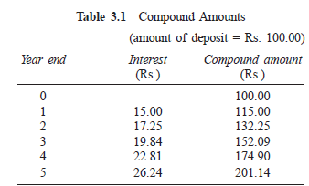

The formula to find the future worth in the third column is F = P X (1 + i)n

Where

*P* = principal amount invested at time 0,

*F* = future amount

*i* = interest rate compounded annually

*n* = period of deposit.

The maturity value at the end of the fifth year is Rs. 201.14. This means that the amount Rs.

201.14 at the end of the fifth year is equivalent to Rs. 100.00 at time 0 (i.e. at present). This is diagrammatically shown in Fig. 3.1. This explanation assumes that the inflation is at zero percentage.

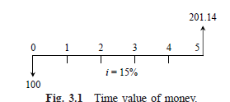

Alternatively, the above concept may be discussed as follows: If we want Rs. 100.00 at the end of the *n*th year, what is the amount that we should deposit now at a given interest rate, say 15%? A detailed working is shown in Table 3.2.

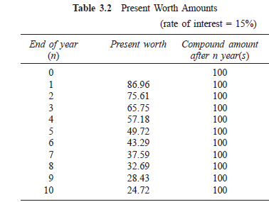

The formula to find the present worth in the second column is



From Table 3.2, it is clear that if we want Rs. 100 at the end of the fifth year, we should now deposit an amount of Rs. 49.72. Similarly, if we want Rs. 100.00 at the end of the 10th year, we should now deposit an amount of Rs. 24.72.

# INTEREST FORMULAS

While making investment decisions, computations will be done in many ways. To simplify all these computations, it is extremely important to know how to use interest formulas more effectively. Before discussing the effective application of the interest formulas for investment- decision making, the various interest formulas are presented first.

Interest rate can be classified into *simple interest rate* and *compound interest rate*.

In simple interest, the interest is calculated, based on the initial deposit for every interest period. In this case, calculation of interest on interest is not applicable. In compound interest, the interest for the current period is computed based on the amount (principal plus interest up to the end of the previous period) at the beginning of the current period.

The notations which are used in various interest formulae are as follows:

*P* = principal amount

*n* = No. of interest periods

*i* = interest rate (It may be compounded monthly, quarterly, semiannually or annually)

*F* = future amount at the end of year *n*

*A* = equal amount deposited at the end of every interest period

*G* = uniform amount which will be added/subtracted period after period to/ from the amount of deposit A1 at the end of period 1

# Single-Payment Compound Amount

Here, the objective is to find the single future sum (*F*) of the initial payment (*P*) made at time 0 after *n* periods at an interest rate *i* compounded every period. The cash flow diagram of this situation is shown in Fig. 3.2

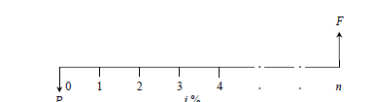

The formula to obtain the single-payment compound amount is

*F* = *P*(1 + *i*)*n* = *P*(*F*/*P*, *i*, *n*)

where

(*F*/*P*, *i*, *n*) is called as single-payment compound amount factor.

***EXAMPLE 3.1*** A person deposits a sum of Rs. 20,000 at the interest rate of 18% compounded annually for 10 years. Find the maturity value after 10 years. ***Solution***

*P* = Rs. 20,000 *i* = 18% compounded annually *n* = 10 years

*F* = *P*(1 + *i*)*n* = *P*(*F*/*P*, *i*, *n*)

= 20,000 (*F*/*P*, 18%, 10)

= 20,000 x 5.234 = Rs. 1,04,680

The maturity value of Rs. 20,000 invested now at 18% compounded yearly is equal to Rs. 1,04,680 after 10 years.

# Single-Payment Present Worth Amount

Here, the objective is to find the present worth amount (*P*) of a single future sum (*F*) which will be received after *n* periods at an interest rate of *i* compounded at the end of every interest period. The corresponding cash flow diagram is shown in Fig. 3.3.

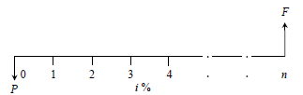

Cash flow diagram of single-payment present worth amount. The formula to obtain the present worth is



Where

(*P*/*F*, *i*, *n*) is termed as *single-payment present worth factor.*

***EXAMPLE 3.2*** A person wishes to have a future sum of Rs. 1,00,000 for his son’s education after 10 years from now. What is the single-payment that he should deposit now so that he gets the desired amount after 10 years? The bank gives 15% interest rate compounded annually.

## Solution

*F* = Rs. 1,00,000

*i* = 15%, compounded annually

*n* = 10 years

*P* = *F*/(1 + *i*)*n* = *F*(*P*/*F*, *i*, *n*)

= 1,00,000 (*P*/*F*, 15%, 10)

= 1,00,000 x 0.2472

= Rs. 24,720

The person has to invest Rs. 24,720 now so that he will get a sum of Rs. 1,00,000 after 10 years at 15% interest rate compounded annually.

# Equal-Payment Series Compound Amount

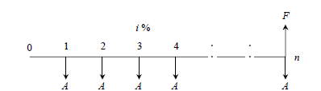In this type of investment mode, the objective is to find the future worth of *n* equal payments which are made at the end of every interest period till the end of the *n*th interest period at an interest rate of *i* compounded at the end of each interest period. The corresponding cash flow diagram is shown in Fig. 3.4.

**Fig. 3.4** Cash flow diagram of equal-payment series compound amount. In Fig. 3.4,

*A* = equal amount deposited at the end of each interest period

*n* = No. of interest periods

*i* = rate of interest

*F* = single future amount

The formula to get *F* is



where (*F*/*A*, *i*, *n*) is termed as *equal-payment series compound amount factor*.

***EXAMPLE 3.3*** A person who is now 35 years old is planning for his retired life. He plans to invest an equal sum of Rs. 10,000 at the end of every year forthe next 25 years starting from the end of the next year. The bank gives 20% interest rate, compounded annually. Find the maturity value of his account when he is 60 years old.

## Solution

*A* = Rs. 10,000

*n* = 25 years

*i* = 20%

*F* = ?

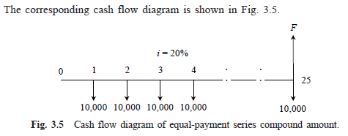

= *A*(*F*/*A*, *i*, *n*)

= 10,000(*F*/*A*, 20%, 25)

= 10,000 x 471.981

= Rs. 47,19,810

The future sum of the annual equal payments after 25 years is equal to Rs. 47,19,810.

# Equal-Payment Series Sinking Fund

In this type of investment mode, the objective is to find the equivalent amount (*A*) that should be deposited at the end of every interest period for *n* interest periods to realize a future sum (*F*) at the end of the *n*th interest period at an interest rate of *i*. The corresponding cash flow diagram is shown in Fig. 3.6.

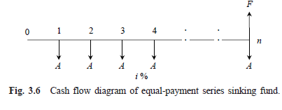

In Fig. 3.6,

*A* = equal amount to be deposited at the end of each interest period

*n* = No. of interest periods

*i* = rate of interest

*F* = single future amount at the end of the *n*th period

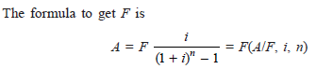

where

(*A*/*F*, *i*, *n*) is called as *equal-payment series sinking fund factor.*

***EXAMPLE 3.4*** A company has to replace a present facility after 15 years at an outlay of Rs. 5,00,000. It plans to deposit an equal amount at the end of every year for the next 15 years at an interest rate of 18% compounded annually. Find the equivalent amount that must be deposited at the end of every year for the next 15 years.

***Solution***

*F* = Rs. 5,00,000, *n* = 15 years *i* = 18% *A* = ?

The corresponding cash flow diagram is shown in Fig. 3.7.

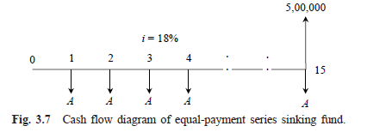



= 5,00,000(*A*/*F*, 18%, 15)

= 5,00,000 x 0.0164

= Rs. 8,200

The annual equal amount which must be deposited for 15 years is Rs. 8,200

# Equal-Payment Series Present Worth Amount

The objective of this mode of investment is to find the present worth of an equal payment made at the end of every interest period for *n* interest periods at an interest rate of *i* compounded at the end of every interest period.

The corresponding cash flow diagram is shown in Fig. 3.8. Here

*P* = present worth *A* = annual equivalent payment *i* = interest rate

*n* = No. of interest periods The formula to compute *P* is

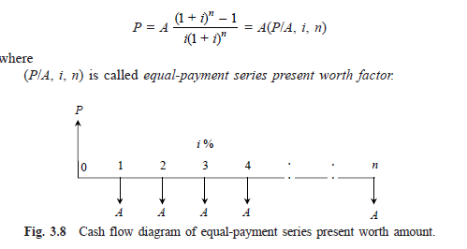

***EXAMPLE 3.5*** A company wants to set up a reserve which will help the company to have an annual equivalent amount of Rs. 10,00,000 for the next 20 years towards its employees welfare measures. The reserve is assumed to grow at the rate of 15% annually. Find the single-payment that must be made now as the reserve amount.

## Solution

*A* = Rs. 10,00,000, *i* = 15%, *n* = 20 years *P* = ?

The corresponding cash flow diagram is illustrated in Fig. 3.9.

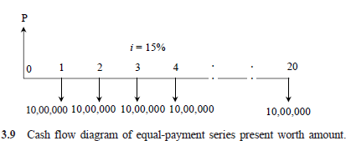



= 10,00,000 x (*P*/*A*, 15%, 20)

= 10,00,000 x 6.2593

= Rs. 62,59,300

The amount of reserve which must be set-up now is equal to Rs. 62,59,300.

# Equal-Payment Series Capital Recovery Amount

The objective of this mode of investment is to find the annual equivalent amount (*A*) which is to be recovered at the end of every interest period for *n* interest periods for a loan (*P*) which is sanctioned now at an interest rate of *i* compounded at the end of every interest period (see Fig. 3.10).

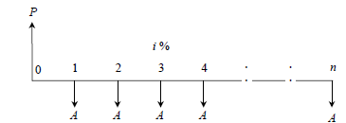

Cash flow diagram of equal-payment series capital recovery amount

In Fig. 3.10,

*P* = present worth (loan amount)

*A* = annual equivalent payment (recovery amount)

*i* = interest rate

*n* = No. of interest periods

The formula to compute *P* is as follows:



where,

(*A*/*P*, *i*, *n*) is called *equal-payment series capital recovery factor*.

***EXAMPLE 3.6*** A bank gives a loan to a company to purchase an equipment worth Rs. 10,00,000 at an interest rate of 18% compounded annually. This amount should be repaid in 15 yearly equal installments. Find the installment amount that the company has to pay to the bank.

***Solution***

*P* = Rs. 10,00,000, *i* = 18% *n* = 15 years *A* = ?

The corresponding cash flow diagram is shown in Fig. 3.11.

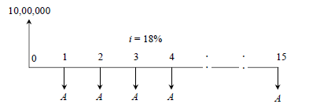 **Fig. 3.11** Cash flow diagram of equal-payment series capital recovery amount.



= 10,00,000 _ (*A*/*P*, 18%, 15)

= 10,00,000 _ (0.1964)

= Rs. 1,96,400

The annual equivalent installment to be paid by the company to the bank is Rs. 1,96,400.

# Uniform Gradient Series Annual Equivalent Amount

The objective of this mode of investment is to find the annual equivalent amount of a series with an amount *A*1 at the end of the first year and with an equal increment (*G*) at the end of each of the following *n* – 1 years with an interest rate *i* compounded annually.

The corresponding cash flow diagram is shown in Fig. 3.12.

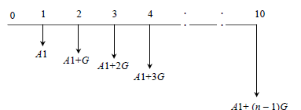

**Fig. 3.12** Cash flow diagram of uniform gradient series annual equivalent amount.

The formula to compute *A* under this situation is

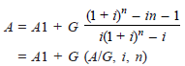

where

(*A*/*G*, *i*, *n*) is called uniform gradient series factor.

***EXAMPLE 3.7*** A person is planning for his retired life. He has 10 more years of service. He would like to deposit 20% of his salary, which is Rs. 4,000, at the end of the first year, and thereafter he wishes to deposit the amount with an annual increase of Rs. 500 for the next 9 years with an interest rate of 15%. Find the total amount at the end of the 10th year of the above series.

## Solution

Here, *A*1 = Rs. 4,000 *G* = Rs. 500 *i* = 15% *n* = 10 years *A* = ? & *F* = ?

The cash flow diagram is shown in Fig. 3.13.

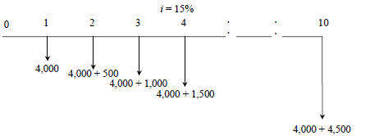

Cash flow diagram of uniform gradient series annual equivalent amount.

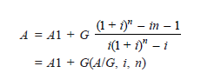

= 4,000 + 500(*A*/*G*, 15%, 10)

= 4,000 + 500 x 3.3832

= Rs. 5,691.60

This is equivalent to paying an equivalent amount of Rs. 5,691.60 at the end of every year for the next 10 years. The future worth sum of this revised series at the end of the 10th year is obtained as follows:

*F* = *A*(*F*/*A*, *i*, *n*)

= *A*(*F*/*A*, 15%, 10)

= 5,691.60(20.304)

= Rs. 1,15,562.25

At the end of the 10th year, the compound amount of all his payments will be Rs. 1,15,562.25.

***EXAMPLE 3.8*** A person is planning for his retired life. He has 10 more years of service. He would like to deposit Rs. 8,500 at the end of the first year and thereafter he wishes to deposit the amount with an annual decrease of Rs. 500for the next 9 years with an interest rate of 15%. Find the total amount at the end of the 10th year of the above series.

***Solution*** Here,

*A*1 = Rs. 8,500, *G* = –Rs. 500, *i* = 15% , *n* = 10 years, *A* = ? & *F* = ?

The cash flow diagram is shown in Fig. 3.14.

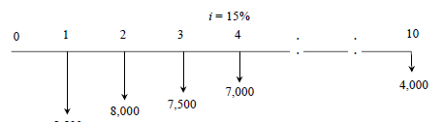

**Fig. 3.14** Cash flow diagram of uniform gradient series annual equivalent amount.

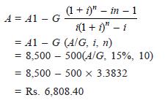

This is equivalent to paying an equivalent amount of Rs. 6,808.40 at the end of every year for the next 10 years.

The future worth sum of this revised series at the end of the 10th year is obtained as follows:

*F* = *A*(*F*/*A*, *i*, *n*)

= *A*(*F*/*A*, 15%, 10)

= 6,808.40(20.304)

= Rs. 1,38,237.75

At the end of the 10th year, the compound amount of all his payments is Rs. 1,38,237.75.

# 3.3.8 Effective Interest Rate

Let *i* be the nominal interest rate compounded annually. But, in practice, the compounding may occur less than a year. For example, compounding may be monthly, quarterly, or semi-annually. Compounding monthly means that the interest is computed at the end of every month. There are 12 interest periods in a year if the interest is compounded monthly. Under such situations, the formula to compute the effective interest rate, which is compounded annually, is

where,

*i* = the nominal interest rate

*C* = the number of interest periods in a year.

***EXAMPLE 3.9*** A person invests a sum of Rs. 5,000 in a bank at a nominal interest rate of 12% for 10 years. The compounding is quarterly. Find the maturity amount of the deposit after 10 years.

***Solution***

*P* = Rs. 5,000, *n* = 10 years, *i* = 12% (Nominal interest rate), *F* = ?

METHOD 1

No. of interest periods per year = 4

No. of interest periods in 10 years = 10 _ 4 = 40 Revised No. of periods (No. of quarters), *N* = 40 Interest rate per quarter, *r* = 12%/4

= 3%, compounded quarterly.

*F* = *P*(1 + *r*)*N* = 5,000(1 + 0.03)40

= Rs. 16,310.19

METHOD 2

No. of interest periods per year, *C* = 4 Effective interest rate, *R* = (1 + *i*/*C*)*C* – 1

= (1 + 12%/4)4 – 1

= 12.55%, compounded annually.

*F* = *P*(1 + *R*)*n* = 5,000(1 + 0.1255)10

= Rs. 16,308.91